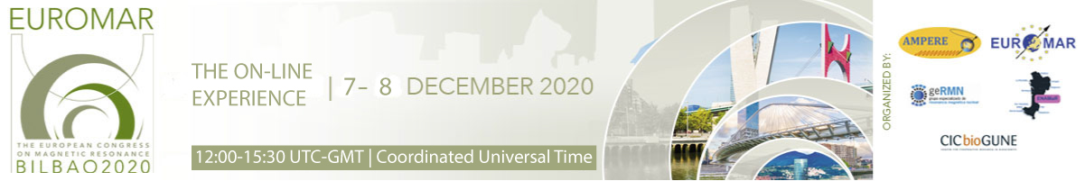

TITLE OF THE ABTRACT (Calibri 14pt Bold, all capital letters)

Authors (Calibri 12 pt, NameA SurnameA¹; NameB SurnameB²;…). Underline the presenting author.

¹Precision Medicine and Metabolism Laboratory, CIC bioGUNE, Basque Research and Technology Alliance, Parque Tecnológico de Bizkaia, Ed. 800. E-48160, Derio, Spain.
²…

Main text (Calibri 12 pt, 300 words max.)
...

References (Calibri 10 pt, 5 refs. max.)
¹ L. Liu, I.-J. L. Byeon, I. Bahar, A. M. Gronenborn, Domain Swapping Proceeds via Complete Unfolding: A ¹⁹ F- and ¹ H-NMR Study of the Cyanovirin-N Protein. J. Am. Chem. Soc. 134, 4229–4235 (2012).

1 Figure allowed.

